Практическая работа №7.

Вариант 1.

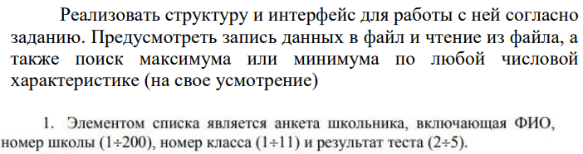

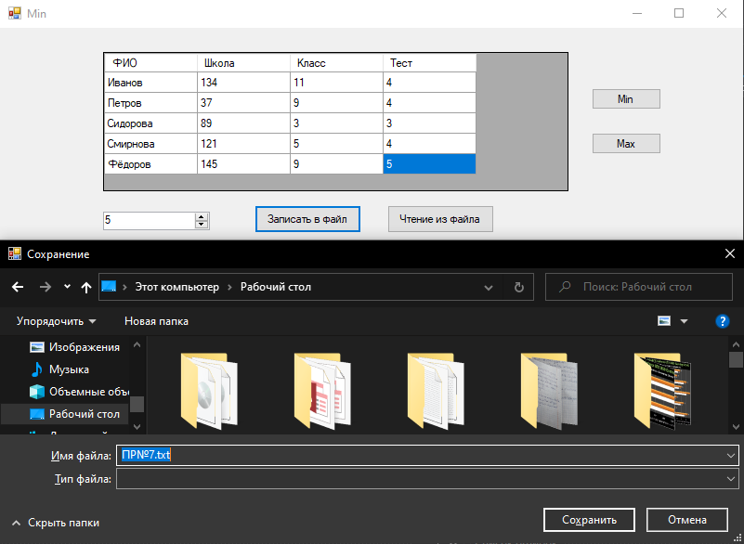

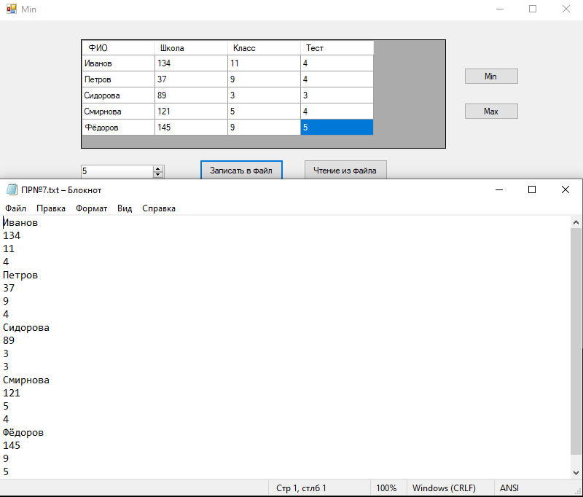

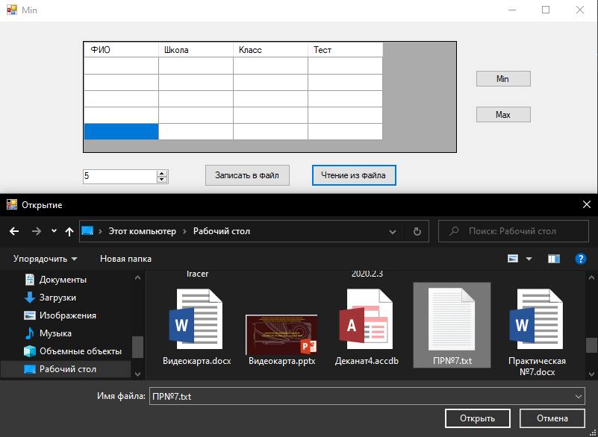

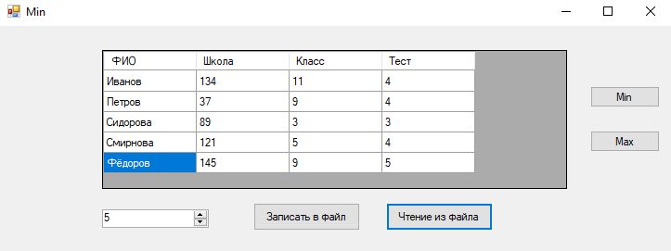

Минимум по классу

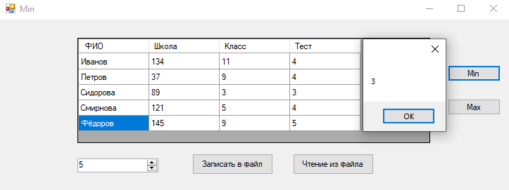

Максимум по классу

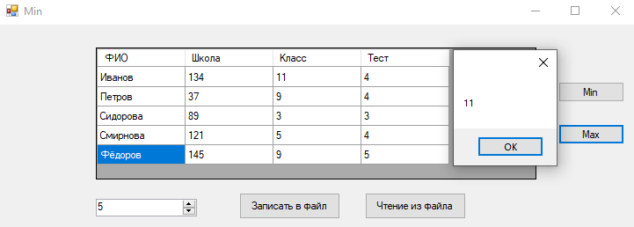

public struct Person

{

public string FIO;

public int school;

public int klass;

public int test;

}

public Form1()

{

InitializeComponent();

}

private void Form1_Load(object sender, EventArgs e)

{

}

private void numericUpDown1_ValueChanged(object sender, EventArgs e)

{

dataGridView1.RowCount = Convert.ToInt32(numericUpDown1.Value);

}

private void button1_Click(object sender, EventArgs e)

{

if (saveFileDialog1.ShowDialog() == DialogResult.OK)

{

int n = Convert.ToInt32(numericUpDown1.Value);

Person[] mas = new Person[n];

for (int i = 0; i < n; i++)

{

mas[i].FIO = dataGridView1[0, i].Value.ToString();

mas[i].school = Convert.ToInt32(dataGridView1[1, i].Value);

mas[i].klass = Convert.ToInt32(dataGridView1[2, i].Value);

mas[i].test = Convert.ToInt32(dataGridView1[3, i].Value);

}

StreamWriter sw = new StreamWriter(saveFileDialog1.FileName,

true, System.Text.Encoding.Default);

for (int i = 0; i < n; i++)

{

sw.WriteLine(mas[i].FIO);

sw.WriteLine(mas[i].school);

sw.WriteLine(mas[i].klass);

sw.WriteLine(mas[i].test);

}

sw.Close();

}

}

private void button2_Click(object sender, EventArgs e)

{

if (openFileDialog1.ShowDialog() == DialogResult.OK)

{

StreamReader sr = new StreamReader(openFileDialog1.FileName,

System.Text.Encoding.Default);

Person[] mas = new Person[0];

int k = 0;

while (!sr.EndOfStream)

{

k++;

Array.Resize(ref mas, k);

mas[k - 1].FIO = sr.ReadLine();

mas[k - 1].school = Convert.ToInt32(sr.ReadLine());

mas[k - 1].klass = Convert.ToInt32(sr.ReadLine());

mas[k - 1].test = Convert.ToInt32(sr.ReadLine());

}

sr.Close();

dataGridView1.RowCount = k;

numericUpDown1.Value = k;

for (int i = 0; i < k; i++)

{

dataGridView1[0, i].Value = mas[i].FIO;

dataGridView1[1, i].Value = mas[i].school;

dataGridView1[2, i].Value = mas[i].klass;

dataGridView1[3, i].Value = mas[i].test;

}

}

}

private void button3_Click(object sender, EventArgs e)

{

int n = dataGridView1.RowCount = Convert.ToInt32(numericUpDown1.Value);

Person[] mas = new Person[n];

for (int i = 0; i < n; i++)

{

mas[i].FIO = dataGridView1[0, i].Value.ToString();

mas[i].school = Convert.ToInt32(dataGridView1[1, i].Value);

mas[i].klass = Convert.ToInt32(dataGridView1[2, i].Value);

mas[i].test = Convert.ToInt32(dataGridView1[3, i].Value);

}

int min = mas[0].klass;

for(int i=0; i<n; i++)

{

if (min > mas[i].klass)

{

min = mas[i].klass;

}

}

MessageBox.Show(min.ToString());

}

private void button4_Click(object sender, EventArgs e)

{

int n = dataGridView1.RowCount = Convert.ToInt32(numericUpDown1.Value);

Person[] mas = new Person[n];

for (int i = 0; i < n; i++)

{

mas[i].FIO = dataGridView1[0, i].Value.ToString();

mas[i].school = Convert.ToInt32(dataGridView1[1, i].Value);

mas[i].klass = Convert.ToInt32(dataGridView1[2, i].Value);

mas[i].test = Convert.ToInt32(dataGridView1[3, i].Value);

}

int max = mas[0].klass;

for (int i = 0; i < n; i++)

{

if (max < mas[i].klass)

{

max = mas[i].klass;

}

}

MessageBox.Show(max.ToString());

}

Ссылка на гитхаб: